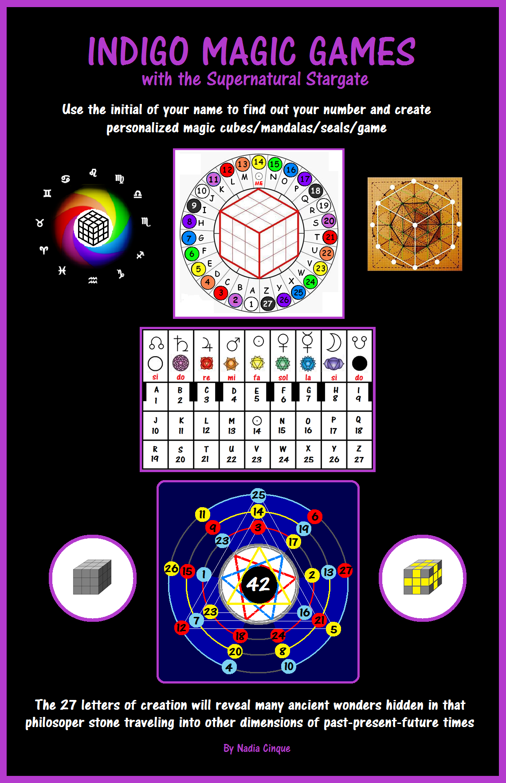

INTRODUCTION

Today people call us Indigo and give us so many different colors and role models we are supposed to represent, but I do not fit in because each one of us is different sometimes with similar gifts like premonitions, out of body travels, messages from our inner self, perception of other people thought etc…I believe in ancient times, we had those super senses active in order to be able to survive in environments full of dangers, predators, enemies and nature probably gave us the proper tools to allow us to survive just like animals still do, knowing what, where, how, when to perform particular tasks enabling their survival, and maybe, in previous times, before our languages and cultures were developed, we too had those similar gifts we lost when we acquired and developed different methods of survival.

I used my gift to search for our past roots to be able to understand what caused our inner metamorphoses through the ages, to become what we are today, able to learn only from external sources and reformatted according to the needs our cultures and religions, but that is not my call, other researchers will have to discover our forbidden and forgotten past sometimes I feel I know, but I do not remember and some ancient symbols seems familiar to me, like a lost common language, once I knew.

Several relatives in my family have similar perceptions like mine, and I found out, those paranormal perceptions were known and used in ancient times, and I was surprised to discover, out of body travels and premonitions dreams/vision when reading Gilgamesh epic or emerald tablets of Thoth or similar readings that were mentioning particular state of mind I experienced in natural ways, so it was nothing new, it is part of our genetic code probably not active or functioning anymore due to many factors, but many people have some of those super senses activated when they have near death experiences, and they all say similar things about out of body travels and ability to perceive the world with other senses and sometimes, when they recover from coma, those super senses, often remain active changing the way life is lived and perceived, sometimes disappear completely or still show up occasionally in particular situations…

This is not the place to mention my many out of body experiences and researches I did, to be able to understand what they were and why I had them and all other paranormal manifestations many others were having too.

I just decided to use this particular and unusual gift, for this kind of magic games I developed during some of my experiments of automatic writings and I am retarded in mathematics, writings, speaking and I do not learn like regular people, for me, it is all more difficult because my mind works differently and my terrible deficit of attention getting worse and worse, makes everything harder.

It is a way to share with you what my inner self perceived, and I used some of that data, to create games using the numeric data of your initial to create your lines of personalized magic art and I used the same codes to develop multidimensional magic cards that can be used for many purposes also as a kind of tarot cards to read our destiny.

I hope you have fun while creating your artistic magic works and experience your own inner magic because nature is magic.

Note:
The central golden image of the multi-dimensional cube you can see on the cover , is one of the original drowings developed during automatic writing and it has the geometric codes used for my philosopher talking stone, showing lots of sacred numbers and data, present in many holy ancient writings, included the Akan calendar of ancient kings, the 27 wives of the Vedic Lunar Deity named Soma, Egyptian sacred doctrines, the Bible, Gilgamesh Epic reporting parallel numeric information encoded in hermetic formats into those writings often connected with celestial movements of stars and calendars vital to our ancestors and present at the roots of all human cultures/religions as the common language once perceived and understood by all.
CHAPTER ONE

Description of codes used for the games

These are the planetary symbols I have used for the games, and their explanations and values according to the order used in ancient seals and magic squares, all related to the days of the week representing those great seven celestial bodies present at the roots of all human cultures and religions and here they are arranged from the first which is Saturn, to the last which is the Moon,, but in the week days, the order of planets is different and you will see in later games, the mysterious differences and similarities between the 2 sequences by creating your 2 magic mandalas using the numeric codes of your name..

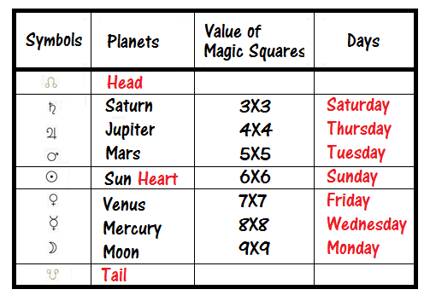

This is a reference table and you will be filling one, replacing those numbers with yours, beginning with the number obtained from the magic wheel.

The start of each line, has the value of white before the 7 chakras matched up with the 7 planets according to my inner perceptions, and the end of each line, we have black. They have notes chosen by me, to represent the vibration of celestial bodies and their planetary symbols used in the table below, are showing the basic universal language of astronomy present at the roots of all human cultures.

Each column is controlled by those leading symbols showed of the first row assigning their value to numbers and letters below them.
So, for example, letter E and number 5, belong to the sun, to the yellow chakra representing it, and to the note fa, the same for the letters and numbers below, the invisible letter of the sun and 14, and again, also letter V and number 23 fall all in the same column therefore possessing the same symbols.

Here the main attributes of 27 numbers starting from 1.
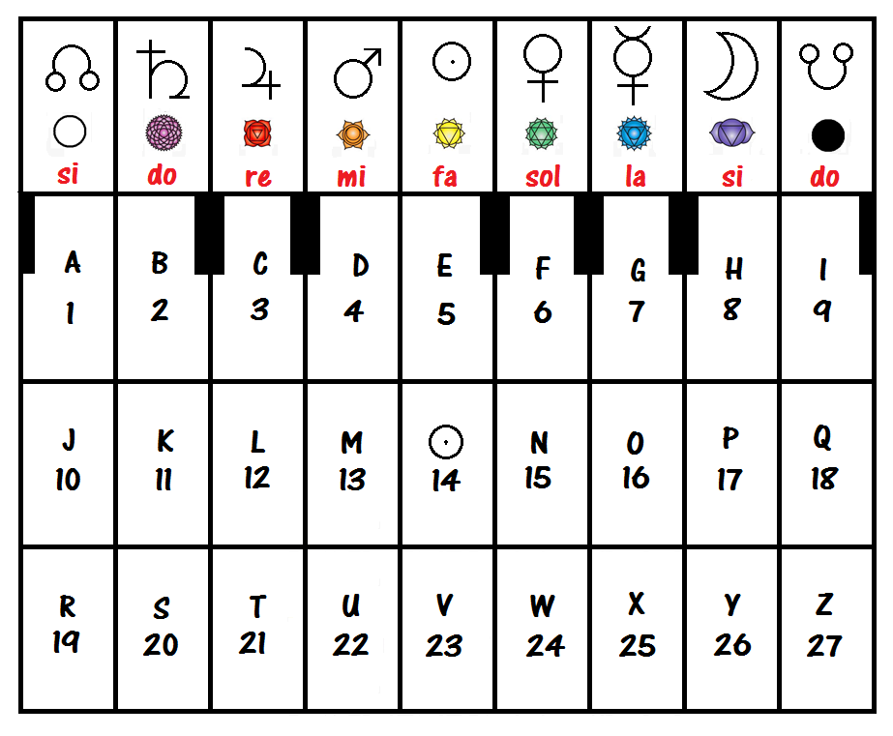

CHAPTER 2

Preparing your matrix

All you have to do to be able to develop these first set of magic games, is to see which number represents the initial of your name using the wheel on the cover of this book and if your name is Bob, your initial is the letter B and its value is 2.

You have to begin from number 2 and continue to fill all the 27 rectangles with consecutive numbers: 2-3-4-5-6-7 etc…continue for the whole alphabet to complete your matrix.

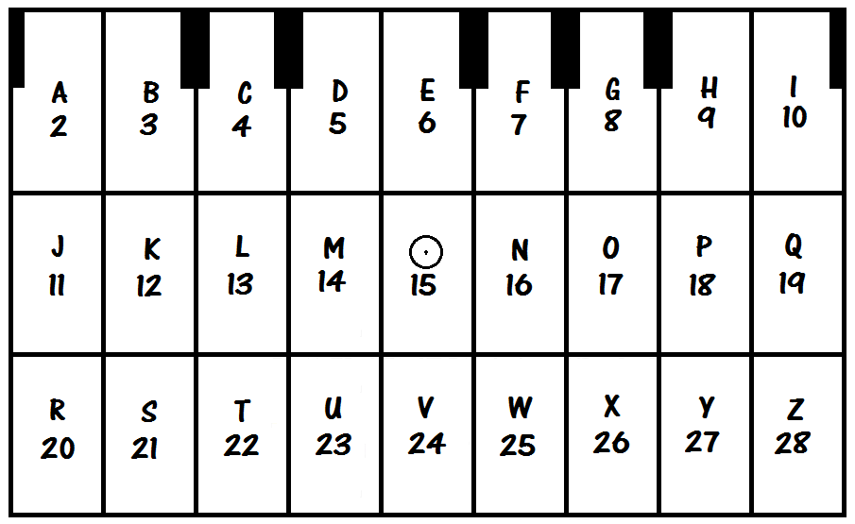

Now you can find your initial number and complete your own matrix, so each letter will have a particular numeric value you will have to copy below the letters I will be using for the magic games personalized with the numeric data of your name.

You will see examples created with the main matrix beginning from number I for Adam, and you can use this empty chart, to fill it with your data and create your own personalized magic art and magic games.

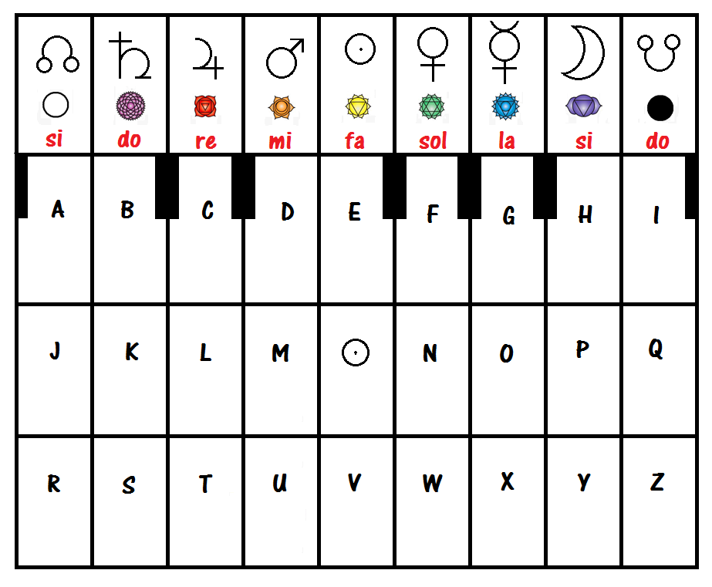

Retro libro con sigilli magici
